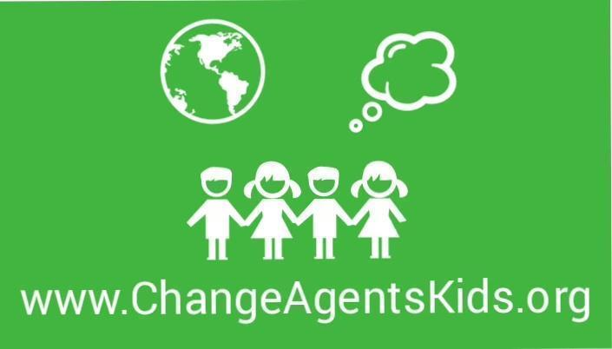
JOIN US IN THE SPRING!

EDUCATE, INSPIRE and EMPOWER children to create POSITIVE CHANGE. Our programs engage children in awareness activities throughout the school year. Lesson plans include fun and exciting ways to teach about challenges faced by our community and our world. Our goal is to empower our students and ensure they know THEIR ACTIONS CAN MAKE AN IMPACT. Past projects include:

- Support for foster animals
- Hunger support
- Relief efforts
- Gratitude exercises
- and many more!
- Grades 1-5, girls & boys

- Available on Tuesday afternoons

  - 4:00 - 5:00 April 5, 19, 26, May 3, 10, 17, 24, 31
  - Eight week session
    - EARLY BIRD PRICING until 3/18 $180. After 3/18 $200.

- Register: Send us an email at info@changeagentskids.org for link to registration. Class will be capped at 15 students in order to better accommodate small group discussions.

For more information check out our website at www.changeagentskids.org or contact us at 301-466-4260.

